“[God gets you to the plate, but once you're there you're on your own.](http://www.azquotes.com/quote/1306902)”

*-Ted Williams[1]*

Business Understanding

There have been two noticeable trends in Major League Baseball over the last five to ten years: a marked decline in the overall level of hitting, from both the standpoint of average and power[2], as well as a similar degree of improvement in the quality of pitching. When trying to explain reasons for the former, experts point to the end of the “Steroid Era”, brought on by the introduction of league-wide testing for performance-enhancing drugs. The subsequent fall in batting performance can then be attributed to a reversion to the mean from artificially inflated numbers.

On the flip side, a number of factors such as advanced metrics and modern improvements in conditioning and preventive arm care have led to a completely new set of rules governing how pitchers are deployed in the game. Whether it is through a conscious reduction of their workloads to decrease stress on their throwing arms, or employing statistically-driven fielding shifts to strengthen defenses behind them, men on the mound are being managed in an increasingly systematic fashion. Recent results speak for themselves, as demonstrated by the decade-long downward trend in league average WHIP (an advanced benchmark designed to gauge a pitcher’s performance against batters- lower is better).

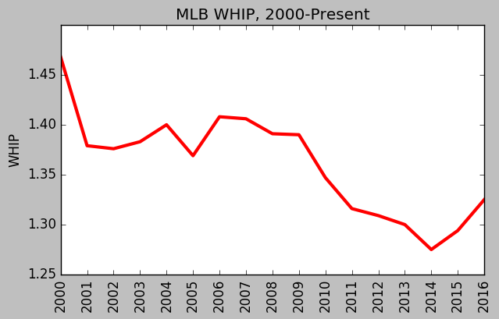

Regardless of whether it is driven by weaker batters, more dominant pitchers or a combination of the two, the issue facing major league franchises and their management is clear: the task of hitting a baseball has become increasingly difficult. Given the abundance of data currently available and the wide acceptance of advanced metrics, isn’t it time to provide hitters with a robust analytical tool that can be used in real time to boost performance? Why not attempt to design a predictive model that can tell them what pitches they can expect to face during every at bat?

The most critical component to any modeling process is a reliable dataset, and MLB already has one in place. Pitchfx is a pitch tracking system that records multiple pitch features including velocity, movement and spin rate for every pitch thrown in a game.[3] It is currently installed in every MLB Stadium and has been in use since 2006. If utilized correctly, it should provide more than enough empirical data to construct reliable, actionable indicators that can be deployed in a real-time game environment.

1. <http://www.azquotes.com/author/15725-Ted_Williams>
2.
3. <http://www.fangraphs.com/library/misc/pitch-fx/>